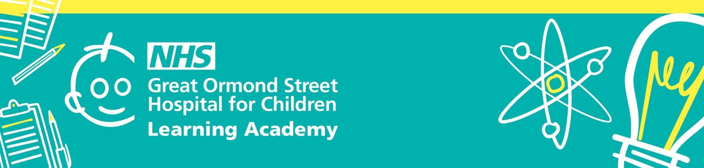

GOSH Paediatric Physician Associate Study Day
Friday February 13th 2026, 9:00 – 17:00
Programme subject to changes
08:45 – 09:15 | Registration & Refreshments
9:15- 9:25 | Welcome & Introduction | Alex Gillingham - Lead Practice Educator: Physician Associates, GOSH  Katherine Aitchison - Physician Associate, SNAPS team, GOSH
9:25 - 10:15 | Paediatric Surgery | Mr Joseph Curry - Paediatric Surgeon in Specialist Neonatal and Paediatric Surgery, GOSH
10:15 - 11:05 | ARFID | Dr Lee Hudson - Consultant General Paediatrician, GOSH
11:05 – 11:20 | Refreshment Break
11:20 – 12:10 | The Limping Child - Radiological Approach | Harry Bliss - Head of Education, ACP
12:10 – 13:00 | Mental Health - trauma informed care | Ellie Parr - Practice Educator: Mental Health
13:00 – 14:00 | Lunch & Networking
14:00 – 15:00 | Anaphylaxis - clinical update | Dr Alexis Bouvier - Consultant General Paediatrician, GOSH
15:00 – 16:00 | LGBTQ+ Inclusive Healthcare | Sarah Brazel-Terris - Specialist Nurse
16:00 – 16:50 | Topic TBC | Ms Zeni Havewala - Consultant Surgeon, SNAPS
16:50- 17:00 | Closing remarks | Alex Gillingham - Lead Practice Educator: Physician Associates, GOSH  Katherine Aitchison - Physician Associate, SNAPS team, GOSH
17:00 | Finish
 | Drinks Social & Networking

